COME HOME
TO A FRESH START 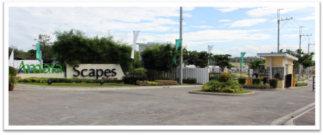
Amaia Scapes Bulacan is a 25 hectares housing development that caters to Filipinos who want to upgrade their status in life, it is Amaia Land’s first project in Bulacan launched in 2013. The project offers enhanced sense of affordable living with its different house and lot units.
For training purposes only
VICINITY MAP
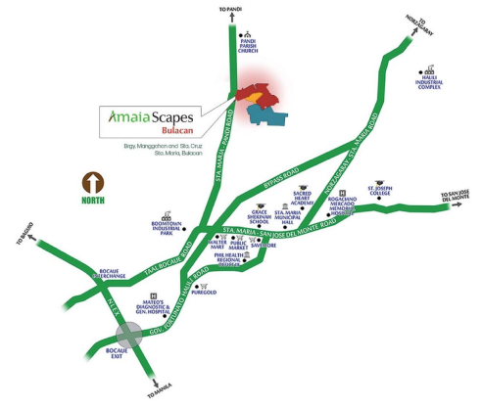
Nearby establishments
• Puregold (1.1KM)
• Waltermart (2.2KM)
• Sta. Maria Municipal Hall (2.2KM) • Grace of Shekinah School (1.6KM) • Sacred Heart Academy (2.2KM) • Mateo’s Diagnostic & General Hospital (2.4KM)
• Ragaciano M. Mercado Memorial Hospital (2.4KM)
• NLEx Bocaue Exit (5.4KM)
• NLEx Skyway Stage 3 (22.5KM)
For training purposes only
OVERALL SITE DEVELOPMENT PLAN 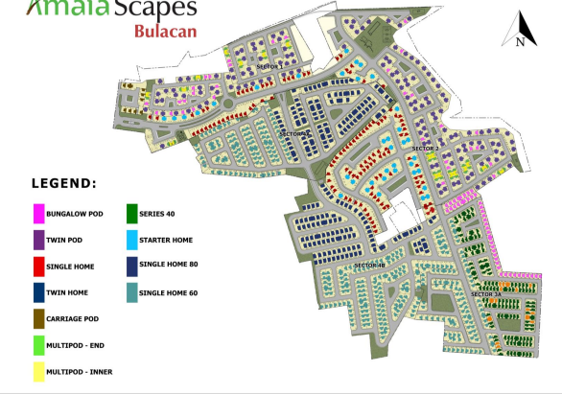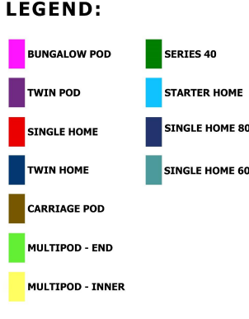For training purposes only
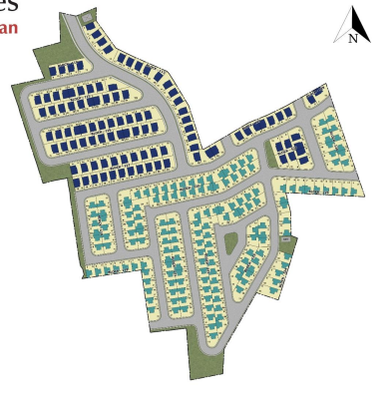
SECTOR 4B SITE DEVELOPMENT PLAN Sector 4B
Land Area: 4.6 hectares
Total units: 271
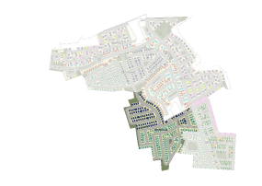
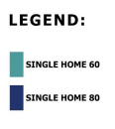
ENTRANCE
For training purposes only
Sector 4B
SINGLE HOME 60
Duplex
Single Attached _{Duplex (select units only)}
LOT AREA: 60 SQM | MIN. LOT AREA: 80 SQM
For training purposes only
Sector 4B
SINGLE HOME 60
3 BEDROOM 2 TOILET & BATH
1 KITCHEN SINK PARKING SPACE (1-2)
*Suggested floor plans only. Actual deliverables may vary depending on the unit & sector. *Parking space shall differ on the actual lot configuration
For training purposes only
Sector 4B
SINGLE HOME 80
Single Attached _{Duplex (select units only)}
LOT AREA: 80 SQM | MIN. LOT AREA: 100 SQM
For training purposes only
Sector 4B
SINGLE HOME 80
3 BEDROOM 3 TOILET & BATH
1 KITCHEN SINK PARKING SPACE (1-2)
*Suggested floor plans only. Actual deliverables may vary depending on the unit & sector. *Parking space shall differ on the actual lot configuration
For training purposes only
UNIT DELIVERABLES SPECIFICATION
 |  | SECTOR 4B
DELIVERABLE | AREA | M60 | M80
FLOORING | Ground Floor Interior Area | Ceramic Tiles | Ceramic Tiles
 | Second Floor Interior Area | Vinyl Planks | Vinyl Planks
 | Porch | Smooth Concrete Finish | Vitrified Floor Tiles
 | Service Area | Smooth Concrete Finish | Smooth Concrete Finish
 | Toilet & Bath at 2F | Ceramic Tiles | Ceramic Tiles
 | Toilet & Bath at GF | Ceramic Tiles | Ceramic Tiles
INTERIOR WALLS | Ground Floor Interior Area | Painted Finish | Painted Finish
 | Second Floor Interior Area | Painted Finish | Painted Finish
 | Toilet & Bath at 2F | Ceramic Tiles & Painted Finish | Ceramic Tiles & Painted Finish
 | Toilet & Bath at GF | Ceramic Tiles & Painted Finish | Ceramic Tiles & Painted Finish
KITCHEN |  | Modular Kitchen Counter and Sink | Modular Kitchen Counter and Sink
TOILET AND BATH | Toilet & Bath at 2F | Complete Toilet & Batch Fixtures | Complete Toilet & Batch Fixtures
 | Toilet & Bath at GF | Complete Toilet & Batch Fixtures | Complete Toilet & Batch Fixtures
WINDOWS |  | Aluminum Framed Windows | Aluminum Framed Windows
DOORS | Main Entry | Steel Door | Steel Door
 | Service Entry | Steel Door | Steel Door
 | Toilet & Bath at 2F | PVC Door | PVC Door
 | Toilet & Bath at GF | PVC Door | PVC Door
 | Bedrooms | MDF Door | MDF Door
PARTITIONS | Bedrooms | Drywall Painted Finish | Drywall Painted Finish
CEILING | Ground Floor Interior Area | Painted Concrete Finish (Underslab) | Painted Board
 | Second Floor Interior Area | Painted Board with insulation | Painted Board with insulation
 | Toilet & Bath at 2F | Painted Board with insulation | Painted Board with insulation
 | Toilet & Bath at GF | Painted Board | Painted Board
STAIRS |  | Concrete steps with vinyl planks, metal framed with cladding and steel railing, tubular steel railing | Painted composite board in metal frame staircase with steel railing
ROOF |  | Pre-painted GI sheet | Pre-painted GI sheet

For training purposes only
COMING SOON
❖Swimming Pool (S4A) ❖Multi-Purpose Hall (S4B)
For training purposes only
COMPLETE ACCESSIBILITY & CONNECTIVITY
RIGHT-SIZED LIVING SPACES
ECO-EFFICIENCY STRUCTURAL STABILITY
• Bike racks are situated near the village
entrance to encourage residents to bike and live a healthier lifestyle
• Lots are relatively bigger, giving sufficient room for future expansion both vertically and horizontally.
• Some units have the flexibility of being
combined for a more
spacious living space.
• Light colored facades and roofs minimize the absorption of heat from the sun.
• Patio greens serve as rain gardens to
replenish the ground
water supply.
• Roofs can withstand winds up to 300 kph. • Sufficient drainage system and access to outfall points.
For training purposes only
SAMPLE COMPUTATION
PAYTERM | SINGLE HOME 60 | SINGLE HOME 80
Selling Price (VAT Inclusive) | P3,700,000 | P4,700,000
10% Down payment | P370,000 | P470,000
Reservation Fee | P20,000 | P20,000
Monthly DP | P11,667 for 30 months | P12,500 for 36 months
BANK FINANCING
5 years | P69,346 | P87,976
10 years | P42,219 | P53,562
15 years | P33,739 | P42,803
20 years | P31,484 | P39,942

For training purposes only
Amaia Scapes Bulacan Sector 4B
DHSUD LTS No. 2021-12-321
Completion Date: April 2023
Barangay Manggahan & Sta. Cruz, Sta. Maria, Bulacan
For training purposes only

